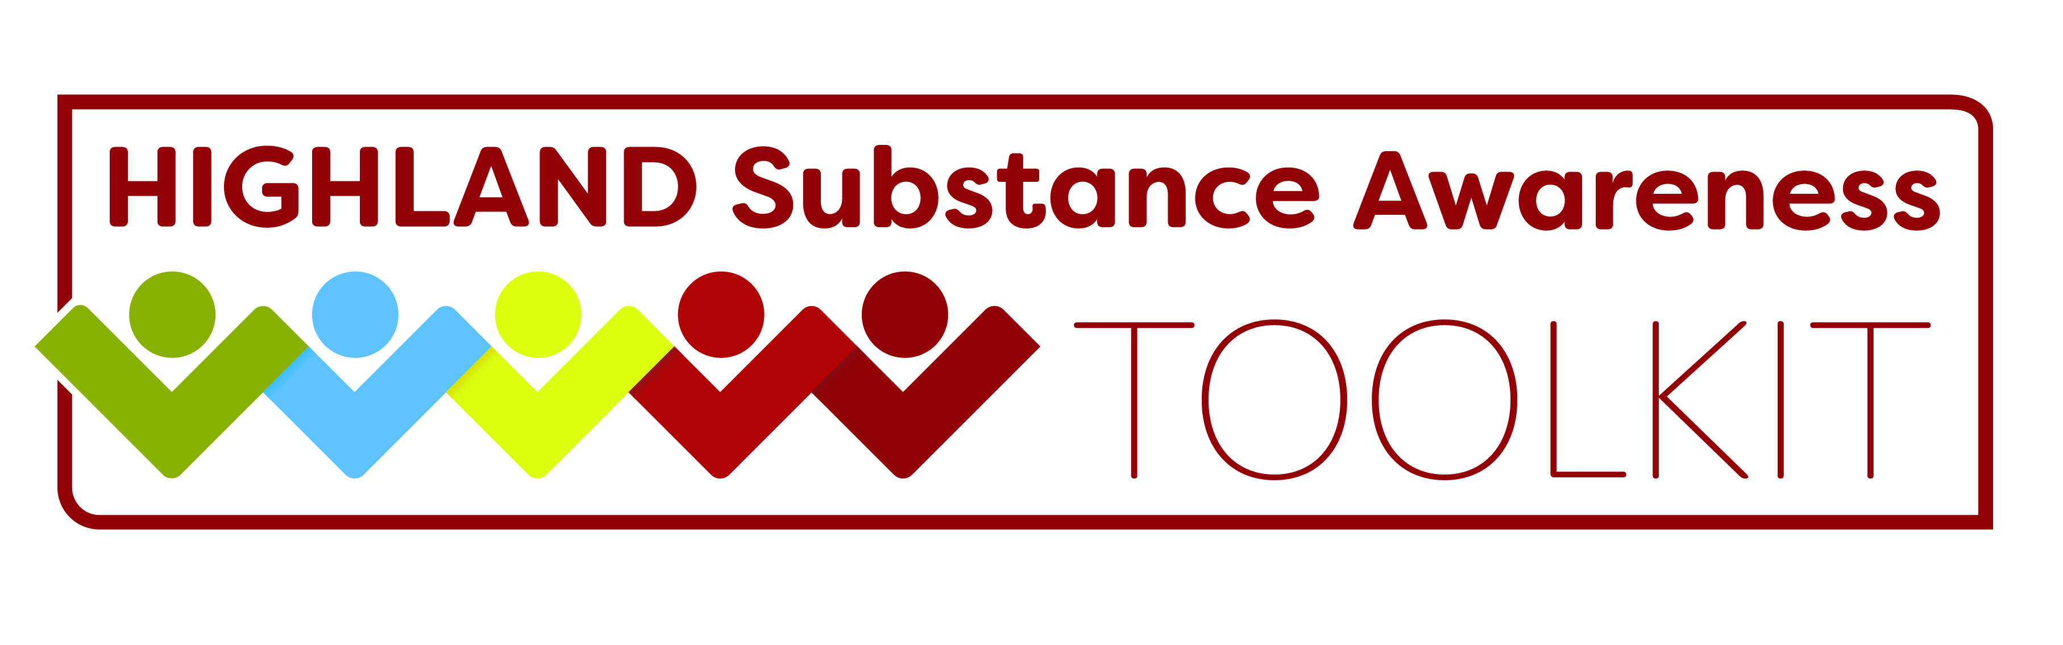

Preventing Substance Use Among Children and Young People
Empowering children and young people through prevention and education in school and beyond
Thursday 21st June 2018 1 - 4.30pm
Culloden and Balloch Baptist Church, Wellside Road, Balloch, Inverness, IV2 7GS
REGISTRATION FORM
Name:
Job title:
Organisation:
Address:
Tel Contact: |  | Email:
Which age group do you usually work with? | Primary School | Secondary School
Please advise if you have any special requirements (including dietary/access):

Please return your completed form to: NHS Highland Health Improvement Training Mailbox: high-uhb.healthimprovementtraining@nhs.net by Friday 8th June 2018. You will receive a confirmation of your place at the event.
Data Protection
Information gathered from this form will only be used for the administration and evaluation of the services provided by the Health Improvement Training Team. We may contact you in future to evaluate the impact of the training. The data will not be shared further unless required by law. If you no longer wish your details to be held, please contact us at:
high-uhb.healthimprovementtraining@nhs.net
The box below must be ticked to give us explicit consent to hold your information:
I consent to my information being held for administration and evaluation of the services provided by the Health Improvement training team and to being contacted in relation to these.
And I understand that I can withdraw my consent at any time.
For details of NHS Highland’s Privacy policy, please see: http://www.nhshighland.scot.nhs.uk/Pages/YourRights.aspx

