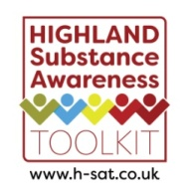
Highland Substance Awareness Toolkit – Lesson Plan Pilot Feedback Sheet – Teachers / Youth Workers
Thank you for agreeing to pilot a selection of the lesson plans. Please complete one sheet per lesson (Teacher / Youth Worker sheet and Children / Young People sheet) and return to: eve.macleod@nhs.scot
Which lesson plan did you pilot? Level:
Name of lesson:
Did the lesson plan meet the stated Curriculum for Excellence Experiences and Outcomes?
No Somewhat Yes
How long did the lesson plan take to complete?
Was the lesson plan clear in its instruction? No Somewhat Yes
How did the young people respond to the lesson?

Would you like to provide any other comments?

Thank you for your input, it is much appreciated, and will help to develop our resources.

Highland Substance Awareness Toolkit – Lesson Plan Pilot Feedback Sheet – Children / Young People
Please pass this around the children / young people to mark this sheet (once per question) to gather their feedback too. Or this could be done as a ‘hands up’ exercise, with the teacher/youth worker inputting numbers.
Q1. Tick the thumb which shows how you felt about this lesson. I thought this lesson was:

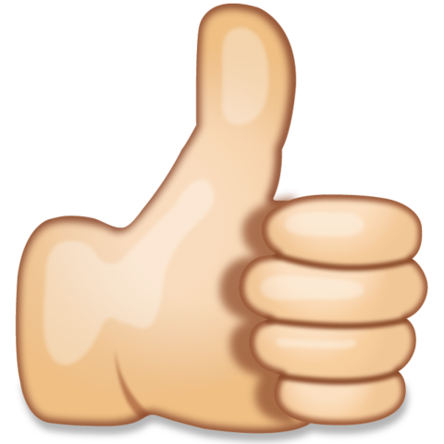

Q2. Tick in the box to show how much you learned. I learned:
Nothing new A little A lot

