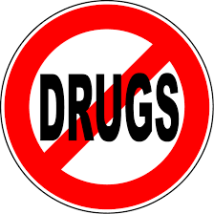DRUGS GAME QUESTIONS

(FACILITATOR COPY)

1) What are the effects of LSD?

[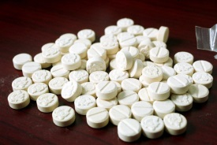](http://www.google.co.uk/url?sa=i&rct=j&q=&esrc=s&source=images&cd=&cad=rja&uact=8&ved=2ahUKEwjI6a2AuKXZAhVQlxQKHVOOCe0QjRx6BAgAEAY&url=http://dyslexiauntied.blogspot.com/2012/04/drugs-speed-and-ecstasy-use-linked-to.html&psig=AOvVaw0vNneQ_RtHvUVE_uGy_boX&ust=1518698636252938)2) Does ecstasy always look like this?

3) Is Ketamine a stimulant drug?

4) The legal high NRG is the same drug no matter where you buy it from?

[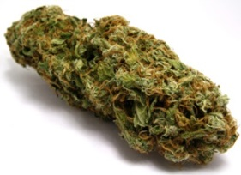](http://www.emcdda.europa.eu/publications/drug-profiles/cannabis)5) What is the name of this substance?

6) Using cocaine can affect your weight.

True/False?

7) In most cases death from ecstasy is caused by the body overheating and dehydration. True/False?

8) Using LSD may lead to mental health problems in the user.

True/False?

9) Legal highs are safe.

True/False

10) How long does it take MDMA (or ecstasy) to reach the brain?

A) 2 minutes

B) 30 to 45 minutes

C) About 1 hour

D) It doesn’t go to the brain

11) Drugs affect people of the same height and weight in the same way.

True/False?

12) Crystal Meth can cause irreversible nerve damage.

True/False?

13) It is safe to drive after smoking marijuana.

True/False?

14) Illegal drugs are put into classes based on how dangerous they are.

True/False?

15) What would the penalty be if you were caught dealing any Class A drug e.g. ecstasy, LSD, heroin?

16) Taking amphetamine (speed) can lead to violence.

True/False

17) Allowing people to use drugs in your home is a crime.

True/False

18) What is the most common illegal drug used by young adults aged 16-34 years?

A) Heroin

B) Cocaine

C) Cannabis

D) MDMA

19) You’re on a night out and your friend is having a ‘bad trip’ what should you do?

20) What are 3 slang names for cannabis?