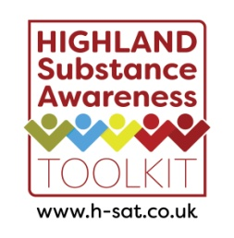
Highland Substance Awareness Toolkit – Quality Assurance Tool
For use in a school context and/or community setting
Please share good examples, photos or products created from these lessons be emailing eve.macleod@nhs.scot

Indicators. The resource: | Met by resource? | Evaluative Comments
Is consistent with principles set out by the Highland Substance Awareness: Prevention and Education Framework
Reflects Experiences and Outcomes for Substance Misuse education and the national standards
Contains health related information that is up-to-date at time of review
Has clear learning intentions and outcomes aligned to Curriculum for Excellence
Can be delivered flexibly and differentiated as appropriate for age, stage and class / group, while still reflecting the Framework
Takes account of relevant protected characteristics and meets the requirements of relevant Equalities legislation
Supports the young person to resist pressures by developing self-confidence and resilience
Suggests or employs different delivery methods, for example group work, role play, discussion, peer inputs etc.
Is evidence based (there is existing evidence that demonstrates the resource’s effectiveness, e.g. research evidence, evaluation). This short e-learning will support this decision.
Supports the option for partnership working in its delivery
Contains information and sign posting to appropriate services and other resources for young people
Is not funded by the alcohol industry

*If there are concerns that a young person may be at risk of significant harm then a discussion should take place with a Practice Lead in the local Family Team and in line with the Highland Child Protection Policy Guidelines.
Adapted with permission from the NHS Greater Glasgow & Clyde Substance Misuse Toolkit Steering Group
October 2021

