**Police Scotland.wmf**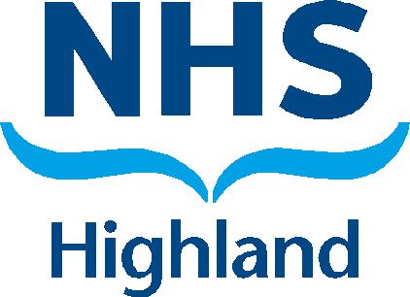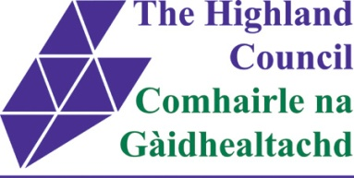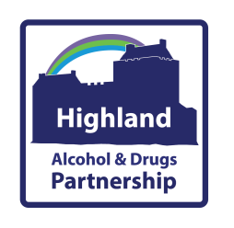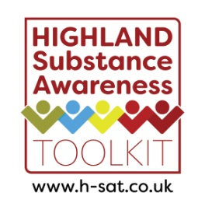

**Substance Aware School Award**

The Substance Aware School (SAS) Award has been developed to recognise and reward consistent, ongoing approaches to prevent substance use among young people across the Highlands. This initiative is a joint partnership between the Highland Alcohol and Drugs Partnership (HADP), the Highland Council, NHS Highland, and Police Scotland. By sponsoring this award we aim to:

* Support and promote evidence informed substance education and prevention in the Highlands
* Celebrate and showcase good practice of substance education and prevention in the Highlands
* Encourage and sustain healthy attitudes and behaviours among young people in the Highlands

The 2019/2020 winners of the SAS Award were informed last week.

The winners of the **Gold** SAS Award and £1,000 are **Smithton Primary School**!

The winners of the **Silver** SAS Award and £500 are **Hilton of Cadboll Primary School**!

The winners of the **Bronze** SAS Award and £250 are **Millburn Academy**!

If you’re interested in applying for the SAS Award next year, keep your eyes on the award page of the Highland Substance Awareness Toolkit, [www.h-sat.co.uk](http://www.h-sat.co.uk).

We look forward to receiving your applications. Good luck!