School Logo
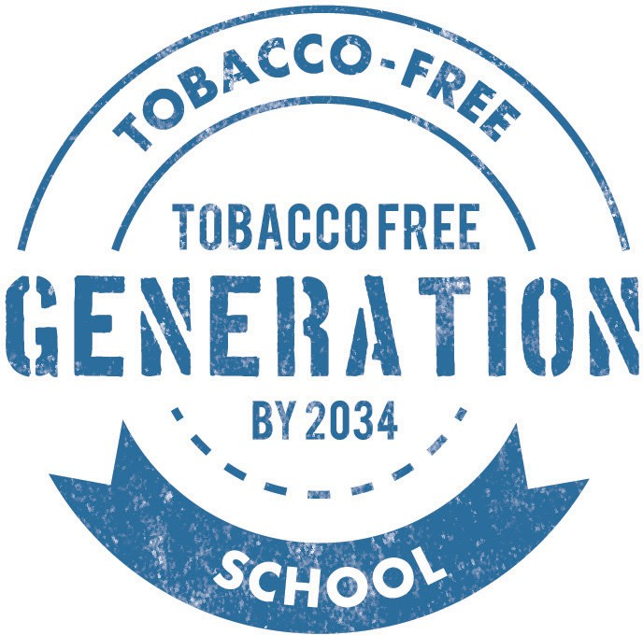

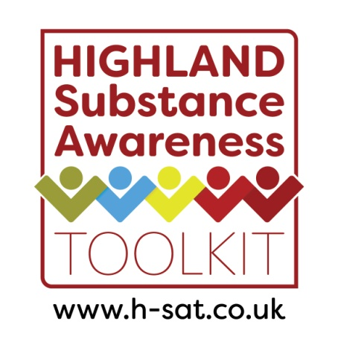
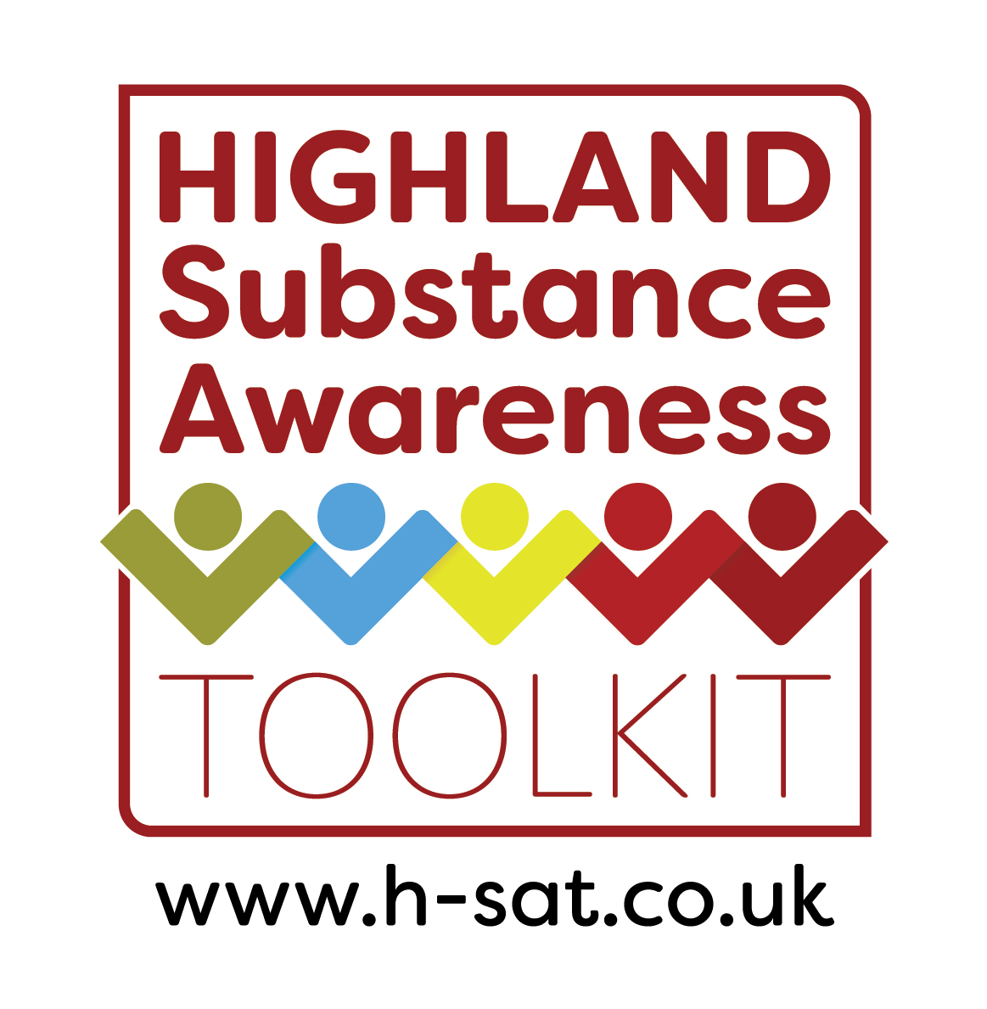

Smoke-free and Substance Aware Policy

Date | Pages and sections affected | Summary of changes | Next Review Date

Contents

Section one: Overview
- [Name of] School: a smoke-free and substance aware school
- Statement of Intent
- Policy Background
- Scope

Section two: Implementing the policy
- Raising awareness of the policy
- Smoking and substance use awareness prevention education
- Support people to quit smoking
- Reducing supply of tobacco to young people
- Dealing with incidents of smoking on campus
- Supporting people with problematic alcohol or drug use
- Reducing alcohol or drug supply to young people
- Dealing with incidents of alcohol or drug use on campus

Section three: Monitoring and evaluation
- Monitoring and evaluation

Appendix 1: Flow chart - smoking

Appendix 2: Flow chart – alcohol / drugs

Section One: Overview
- [Name of] School: a smoke-free and substance aware school

Becoming a smoke-free and substance aware school expresses [Name of] School’s commitment to the health, wellbeing and future life of our school community. In this policy we provide a framework of effective support and encouragement for young people to live smoke-free and substance aware lives.

  - Our smoke-free and substance aware school approach goes beyond defining where smoking is and is not permitted and aims to ensure that [Name of] School is a safe and healthy learning and working environment by ensuring that our young people, staff and visitors are not exposed to smoke and smoking behaviour and that we provide our pupils with the right information at the right time to help them to become substance aware and make positive choices around any substance use.

Statement of Intent

  - The school will actively work to ensure that all areas are smoke and substance free. Staff and students have the right to work and learn in a smoke and substance free environment.

  - The school, with the support of partner agencies, will provide age appropriate information and education to pupils to encourage them to become substance aware, in line with the evidence base.

  - The school will do all that is necessary to ensure all staff, pupils, visitors and contractors are made aware of the policy.

  - [Name of] School will help those who wish to stop smoking and work in partnership with agencies including the NHS to provide a supportive environment to do so.

  - All staff at [Name of] School are role models to the young people in our care. This means that all staff will play an active role in implementing, communicating and supporting our smoke-free and substance aware policy within our school. This is part of the GTCS Standard for Registration http://www.gtcs.org.uk/web/FILES/teacher-regulation/copac-0412.pdf and also as an employee of Highland Council https://www.highland.gov.uk/peopleandperformance/downloads/file/168/code_of_conduct_v01.

  - [Name of] School will implement measures to work with agencies to help reduce young people’s access to tobacco products and other substances in school and the local community.

  - [Name of] School will work to ensure our tobacco prevention education is up-to-date and delivered across year groups and curriculum areas to provide young people with effective education to help them make informed choices on tobacco and health. The same applies to age appropriate information regarding other substances.

  - [Name]; Head Teacher within [Name of] School, has overall responsibility for policy enforcement and policy monitoring. Should you have a question or complaint regarding smoking within campus grounds or education concerning substance awareness: Email: [insert] or Telephone: [insert]

  - Child Protection is Everyone’s Responsibility. [Name of] School will comply with established Child Protection protocol to ensure proportionate responses to concerns, allowing children to receive support as required. We can access further advice and support from Highland Child Protection Committee at http://www.hcpc.scot.
May 2020

If there are concerns that a young person may be at risk of significant harm then a discussion should take place with a Practice Lead in the local Family Team and in line with the Highland Child Protection Guidance.

Policy Background:

  - [Name of] School’s smoke-free and substance aware policy was developed in [school year] following a review and consultation with pupils, teaching staff, support staff, parent, carers and community partners. Its development occurred due to: [insert information about how and why this policy began to be developed].

The policy will be fully implemented from [insert] in accordance with [Name of] School’s smoke-free and substance aware action plan [develop to support plans].
  - Curriculum for Excellence and GIRFEC are clear that protecting and promoting the health and wellbeing of young people is fundamental to the role of all schools. Schools, teachers and staff have a vital role to play in supporting and nurturing young people to make healthy life decisions as they make the transition into adulthood, employment, training and further education.
  - The United Nations Convention the Rights of the Child states that every child has the right to the best possible health and children have the right to effective education on health and wellbeing. Like the UNCRC, [Name of] School smoke-free and substance aware policy seeks to encourage adults to involve children, be responsible for them and use their power to help keep them safe, healthy and protected from harm.
  - One of the core elements of the Scottish Government’s tobacco control strategy (2013) is smoking prevention with the key aim being to create an environment where young people do not want to smoke. To support this, the strategy requires all Local Authorities to implement fully smoke-free policies across their buildings and surrounding grounds.
  - The Smoking, Health and Social Care (Scotland) Act 2005 and the Prohibition of Smoking in Certain Premises Regulations 2006 are central to this policy. The Local Authority Smoking at Work Policy https://www.highland.gov.uk/peopleandperformance/downloads/file/484/smoking_at_work_policy provides a strong focus on compliance and enforcement with regard to smoke-free legislation. The [Name of] School smoke-free and substance aware policy complements this by promoting a whole school ethos that supports and encourages young people to make healthy behaviour choices.
  - The Local Authority policy regarding substance use https://www.highland.gov.uk/peopleandperformance/downloads/file/341/substance_misuse_guidance also supports our aim to be smoke free and substance aware at [Name of] School.
  - [Name of] School has endorsed the principles of Scotland’s Charter for a Tobacco-free Generation and pledged to help reduce the harm caused by smoking and deliver a tobacco-free generation by 2034. This demonstrates our school’s commitment to playing our part in making Scotland a healthier, wealthier place to grow, learn, play and work.

Scope
  - This Policy applies to all people using the facilities: staff, pupils, users of the facilities, customers, visitors, contractors and hirers of the building.
  - School partnership organisations and contractors working on the premises are expected to adhere to the policy.
  - [Name of] School is proud to be a health promoting, smoke-free school therefore smoking is not permitted in [Name of] School’s building and throughout the grounds within the fenced parameters at any time and including private vehicles. [Name of] School do not endorse parents / carers or other visitors to the school smoking, drinking, or using other substances at our school.
  - The policy also applies during other school events, school trips and off-campus activities where pupils are under the care and supervision of [Name of] School staff. We will not provide / allow / serve alcohol at school events, whether pupils are present or not. We will not organise school trips to alcohol industry endeavours.

4.4.1 Smoking is defined as any activity that involves the use of a burned tobacco product. Products that imitate cigarettes or produce vapour are also included in this definition at present.
    - E-cigarettes: Although [Name of] School supports access to nicotine containing products for those who smoke who wish to cut down or stop, it is concerned e-cigarettes and vaping devices may attract non-smokers, including young people. New legislative measures also prohibit the sale of Nicotine Vapour Products (NVPs) to under 18s (Health (Tobacco, Nicotine etc. and Care) (Scotland) Act).
This is why [Name of] School has taken the decision to include the use of e-cigarettes in our smoke-free policy. This follows guidance issued from NHS Health Scotland: there is still a lot we do not know about e-cigarettes. They are not risk free and access to e-cigarettes needs to be controlled carefully; they are not products for children or non- smokers. To avoid confusion on the interpretation of the smoke-free policy e-cigarettes will be prohibited from use within the school campus by all staff, pupils and visitors.

Section Two: Implementing the Policy

Raising awareness of the policy

  - [Name of] School wishes to support people to adhere to the policy and will take every available action to ensure this is the case by making people aware of the policy and their responsibilities herein.

  - The school will raise awareness of the smoke-free and substance aware policy to staff, students, parents, partner organisations, contractors and members of the public using a range of methods. To ensure the whole school community is aware of the policy and our ambition to protect against harms caused by substances we will undertake the following actions:
- Utilising the school social media accounts
- Ensuring the policy will be available on the school website
- Making all contractors and hirers of the building made aware of the policy
- Displaying smoke-free school signage in prominent areas of the school, including the car park and all entrances
- Providing information on the policy to all staff
- Ensuring that staff and student induction processes include information about the policy and approaches
- Staff inductions will include full briefing of the smoke-free and substance aware policy
- The school website will feature the benefits of becoming a smoke-free and substance aware school and carry the smoke-free school logo
- There will be an annual review to the policy with relevant partners to ensure that it remains up to date with regards to new legislation.

Smoking and substance use prevention education

  - Education is a key element in this policy. Providing young people with knowledge of the harmful effects of smoking and substance use will help equip them to make confident and responsible decisions on smoking, substance use, and their health and wellbeing.

Therefore:
    - We will use the Highland Substance Awareness Toolkit lesson plans as appropriate with each stage throughout each school year.
    - We will have a whole school focus on cross-curricular work from January to March each year will promote the build-up to the annual National No- Smoking Day in March. [example suggestion]
    - All class teachers will be encouraged to embed relevant tobacco, alcohol and drug prevention messages into course programmes where opportunities arise.
    - We will not accept funding, or input, from alcohol industry funded sources.

  - The substance prevention education delivered at [Name of] School will be reviewed and updated annually in line with the Highland Substance Awareness Toolkit to ensure the content and delivery it is up-do-date, relevant and addressing new and emerging issues. The Highland Substance Awareness Toolkit can be found here: https://www.h-sat.co.uk
  - Teaching staff and support staff will have opportunities to engage with relevant training, access to resources and other CPD opportunities to ensure they are equipped to deliver substance prevention education. Free training is available via NHS Highland Health Improvement team, details available at https://www.nhshighland.scot.nhs.uk/YourHealth/Pages/HealthImprovementTraining.aspx

Supporting people to quit smoking
  - To reduce the harm caused by smoking, staff, pupils and visitors will be signposted to support to stop smoking as appropriate. [Name of] School will help those who wish to stop smoking and work in partnership with agencies including the NHS to support them.
  - Site users who smoke are encouraged to seek help from local pharmacies or NHS smoking cessation services.
  - Pupils identified as smoking will also be signposted to relevant support and/ or referred onto the local smoking cessation service and parents will be notified.
  - Reasonable requests from staff for time to attend smoking cessation appointments will be treated sympathetically by their line manager. Staff who require smoking cessation medication may wish to seek advice from NHS Highland Smoke-free Service, their GP or pharmacy.
  - Sources of support are:
- Quit Your Way www.quityourway.scot 0800 84 84 84
- Local smoking cessation service visit www.smokefreehighland.co.uk or email high-uhb.stopsmoking@nhs.net​
- Community Pharmacy services

Reducing tobacco supply to young people
  - [Name of] School will work closely with local businesses and trading standards services in order reduce young people’s access to tobacco products.
  - Where the school has information on young people being supplied with tobacco this information will be passed to trading standards. Trading standards can be contacted through:

Highland Council Trading Standards: Tel: 01463 644570

Email: tradingstandards@highland.gov.uk
  - Young people are often able to access cigarettes by buying them, or being given them by other people. The sharing or selling of cigarettes between peers is a clear breach of [Name of] School’s policy. Pupils should not bring any tobacco products (including e-cigarettes) to school with them.

Dealing with incidents of smoking on campus

  - It is everyone’s responsibility to ensure that [Name of] School campus remains smoke-free. All members of staff are required to advise those seen smoking that it is not permitted, draw attention to the smoke-free policy and report incidents to [name]; Head Teacher.
  - [Name of] School is proud to be a health promoting, tobacco free school. All staff, pupils and visitors at [Name of] School are strongly encouraged to recognise their role modelling influence and not smoke or knowingly permit smoking within the school grounds.
  - Everyone at [Name of] School has a right to clean air and a healthy learning environment. Appendix 1 shows a flow chart for dealing with smoking on campus.

Non-pupil smoking on campus:
  - Staff, contractors, visitors and members of the public who persistently breach the policy will be reminded about the importance to compliance, directed to off-campus grounds where they are permitted to smoke and will be reported to their host organisation (if applicable).
  - If the person continues to smoke or challenges the policy, report the non-compliance to [name]; Head Teacher by providing a note of where and when the incident took place and the name of the person involved and a note of the outcome of the discussion.
  - Persistent and wilful breaches of the policy from adults may result in them being asked to leave the premises.

Pupils smoking on campus:
  - In the case of pupils smoking within the school grounds, they should be asked to stop and reminded of the smoke-free policy in the first instance. All incidents of pupils smoking should be reported to [Name]; Head Teacher for follow-up.
  - Pupils identified as smoking will:
- Have cigarettes/vaping devices confiscated
- Have a conversation about their smoking with a member of the Senior Management Team
- Phone call home
- Referral to stop-smoking services (if willing)
- Completion of pastoral notes to record incident and any follow up.

9.8 The school wishes to support people to adhere to the policy in the first instance and will take supportive action to ensure this is the case. Persistent and wilful breaches of the policy may result in the matter being dealt with through school disciplinary procedures.

Supporting people with problematic alcohol or drug use
  - To reduce the harm caused by substances, staff, pupils and visitors will be signposted to support for problematic alcohol or drug use as appropriate. [Name of] School will help those who require support and work in partnership with agencies including the NHS to support them.
  - Site users who require support are encouraged to seek help from NHS or third sector services.
  - Pupils identified as using substances will also receive support from and/ or referred onto the Highland Youth Action Team.
  - Reasonable requests from staff for time to attend appointments will be treated sympathetically by their line manager. Staff who require medication support may wish to seek advice from NHS Highland, their GP or pharmacy.
  - Sources of support are:
- The Drug and Alcohol Recovery Service – 01463 716888
- Highland Alcohol and Drug Advice and Support Service – 01463717594
- Highland Youth Action Team – 01463 256600
- Other routes of support are detailed in the Highland Alcohol and Drugs Partnership Service Directory https://www.highland-adp.org.uk/userfiles/file/service_directory/Directory-of-Services-24122018.pdf
- The Prevention and Intervention Model on the Highland Substance Awareness Toolkit would also be useful for intervention and support if pupil substance use occurs https://www.highlandsubstanceawareness.scot.nhs.uk/prevention-intervention-model/

Reducing alcohol or drugs supply to young people
  - [Name of] School will work closely with local businesses and Police Scotland in order reduce young people’s access to alcohol or drugs.
  - Where the school has information on young people being supplied with alcohol or drugs this information will be passed to Police Scotland.
Police Scotland can be contacted through:

Northern Police, Police Scotland

Tel: 01463 228411

  - Young people may be able to access alcohol or drugs by buying them, or being given them by friends. The sharing or selling of alcohol or drugs between peers is a clear breach of [Name of] School’s policy. Pupils should not bring any alcohol or drug products to school with them.

Dealing with incidents of alcohol or drug use on campus

  - It is everyone’s responsibility to ensure that [Name of] School remains substance free. All members of staff are required to advise those seen using substances, or under the influence of substances, that it is not permitted, draw attention to the policy and report incidents to [name]; Head Teacher.
  - [Name of] School is proud to be a health promoting, smoke free and substance aware school. All staff, pupils and visitors at [Name of] School are strongly encouraged to recognise their role modelling influence and not use substances or knowingly permit substance use within the school grounds.
  - Everyone at [Name of] School has a right to a safe and healthy learning environment. Appendix 2 shows a flow chart for dealing with substance use on school grounds.

Non-pupil substance use on campus:
  - Staff, contractors, visitors and members of the public who persistently breach the policy will be reminded about the importance to compliance, directed to off school grounds and will be reported to their host organisation (if applicable).
  - If the person continues to challenge the policy, report the non-compliance to [name]; Head Teacher by providing a note of where and when the incident took place and the name of the person involved and a note of the outcome of the discussion.
  - Persistent and wilful breaches of the policy from adults will result in them being asked to leave the premises.

Pupil substance use on campus:
  - In the case of pupils using substances within the school grounds, they should be asked to stop and reminded of the policy in the first instance. All incidents of pupils’ substance use should be reported to the [name]; Head Teacher for follow-up.

Pupils identified as having substances will:
- Have alcohol / drugs confiscated
- Have a conversation about their substance use with a member of the Senior Management Team
- Phone call home
- Referral to Youth Action Team services (with parental agreement)
- Completion of pastoral notes to record incident and any follow up.

12.8 The school wishes to support people to adhere to the policy in the first instance and will take supportive action to ensure this is the case. Persistent and wilful breaches of the policy may result in the matter being dealt with through school disciplinary procedures.

Section Three: Monitoring and Evaluation
  - [name]; Head Teacher will monitor and evaluate the number of instances of breaches of the Policy.
  - Monitoring and evaluation will take place as required.
  - The policy will be reviewed every year (from 20XX onwards).
  - The smoke-free and substance aware policy will be referenced and accessible on [Name of] School’s website under Key Policies [for example]: [include address]

Appendix 1: Flow Chart - Smoking
It is everyone’s responsibility to ensure that the campus remains smoke-free. Whilst there are many different factors which lead young people to smoke, the extent to which tobacco is prominent, normal or accepted in environment around them plays a crucial part. Healthy role-modelling helps stimulate a culture and attitude change around smoking and creates a cleaner, safer and healthier learning environment and workplace.
All members of staff are required to advise those seen smoking that it is not permitted and report incidents to named designated person. All staff, pupils and visitors at [Name of] School are strongly encouraged to recognise their role modelling influence and not smoke or knowingly permit smoking within the school grounds.
This establishes the series of actions to be taken once an individual has been identified as smoking on campus.
Staff
Asked to stop and reminded of policy
Inform senior management contact
Incident recorded and support offered
Signpost to stop- smoking support
Follow-up within two weeks to offer further support
Contractor or Visitor
Asked to stop and reminded of policy
Inform senior management contact
Incident recorded and reported to host organisation
Member of Public
Asked to stop and reminded of policy
Inform senior management contact
Incident recorded and support offered
(if applicable)
Signpost to stop- smoking support (if appropriate)
If the person continues to challenge the policy, report the non- compliance to the appropriate person by providing a note of where and when the incident took place and the name of the person involved and a note of the outcome of the discussion.
Persistent and wilful breaches of the policy from adults may result in the being asked to leave the premises

Pupils
Confiscate
cigarettes / vape
(if possible)
Asked to stop smoking and reminded of the smoke-free policy
Inform senior management contact
Supportive conversation with pupil and parent & incident recorded
Support accepted
Support
declined
Referral made to stop smoking support
If there’s a reoccurrence of smoking on school grounds inform parent or carer
Follow-up as required
Follow-up as required

Appendix 2: Flow Chart – Alcohol / Drugs
It is everyone’s responsibility to ensure that the school remains substance-free. Whilst there are many different factors which lead young people to use substances, the extent to which alcohol or drugs are prominent, normal or accepted in environment around them plays a crucial part. Healthy role-modelling helps stimulate a culture and attitude change around substance use and creates a safer and healthier learning environment and workplace.
All members of staff are required to advise those seen using, or under the influence of substances that it is not permitted and report incidents to named designated person. All staff, pupils and visitors at [Name of] School are strongly encouraged to recognise their role modelling influence and not and not use substances or knowingly permit substance use within the school grounds.
This establishes the series of actions to be taken once an individual has been identified as using substances on school grounds.
Staff
Asked to stop and reminded of policy
Inform senior management contact
Incident recorded and support offered
Signpost to support services support
Follow-up as appropriate to offer further support
Member of Public
Asked to stop and reminded of policy
Inform senior management Contact
Incident recorded and support offered
(if applicable)
Signpost to support services (if appropriate)
Contractor or Visitor
Asked to stop and reminded of policy
Inform senior management Contact
Incident recorded and reported to host organisation
If the person continues to challenge the policy, report the non- compliance to the appropriate person by providing a note of where and when the incident took place and the name of the person involved and a note of the outcome of the discussion.
Persistent and wilful breaches of the policy from adults may result in the being asked to leave the premises

Pupils
Confiscate
alcohol / drugs
(if possible)
Asked to stop and reminded of the substance-free policy
Inform senior management contact
Supportive conversation with pupil & parent, & incident recorded
Support
accepted
Support
declined
Referral made to Youth Action Team

If there’s a reoccurrence of use on school grounds inform parent or carer
Follow-up as required
Follow-up as required

