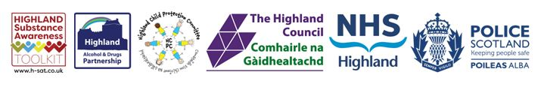

Substance Aware School Award
The Substance Aware School (SAS) Award has been developed to recognise and reward consistent, ongoing approaches to prevent substance use among young people across the Highlands. This initiative is a joint partnership between the Highland Alcohol and Drugs Partnership (HADP), the Highland Council, NHS Highland, Police Scotland, and the Highland Child Protection Committee. By sponsoring this award we aim to:
- Support and promote evidence informed substance education and prevention in the Highlands
- Celebrate and showcase good practice of substance education and prevention in the Highlands
- Encourage and sustain healthy attitudes and behaviours among young people in the Highlands

The 2020/2021 winners of the SAS Award were informed recently.

The winners of the Gold SAS Award and £1,000 are Smithton Primary School!

If you’re interested in applying for the SAS Award next year, keep your eyes on the award page of the Highland Substance Awareness Toolkit, www.h-sat.co.uk.
We look forward to receiving your applications. Good luck!

