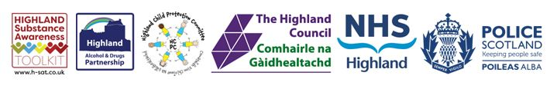

Substance Aware School (SAS) Award 2023/2024 Application Form

The SAS Award aims to celebrate and showcase good practice across the Highlands. You are asked to tick here to confirm that you are prepared to be actively involved in publicising the work that you have done:

Please provide the name, and contact details of your school, including your email address.

Please describe in what ways your school has met the following criteria.
Please support your application with pictures and / or examples of work, which could be used to further celebrate and showcase good practice across the Highlands.

1. Demonstrate how the Highland Substance Awareness: Education and Prevention Framework has informed substance prevention and / or education (e.g. use of accompanying lesson plans):

2. Describe ways in which the Highland Substance Awareness Toolkit (H-SAT) has been accessed, utilised, or promoted:

3. Develop or review the school’s substance policy, ensuring it is up to date and complied with (this may form part of the school’s improvement plan):

4. Encourage, support, or provide positive / diversionary activities:

5. If you were successful in achieving a SAS Award, please state how you would use the prize money to further develop substance education and prevention approaches, such as positive or diversionary activities, or family centred activities:

6. Please tell us how you plan to evaluate these activities? (e.g. describe the three main benefits of the activities, who they would benefit (e.g. young people, parents / carers, the local community):

Which groups of children and young people do you include (please tick all that apply):
3 - 5 years | 6 – 11 | 12 – 18 years
Children with additional support needs
Children living in an area of deprivation
Looked after children
Young carers
Other group (please specify below)

How many children have benefited from the input? (Please note that higher numbers will not be key criteria as circumstances and quality will be taken into account):

Please send your completed application to stephanie.tyrer@nhs.scot.

Applications are open from Monday the 11th December 2023 to the closing date of Friday 1st March 2024.

Applications will be considered before announcing the winners.

We look forward to receiving your applications. Good luck!

